1. import java.util.*;

class BankAccount {
int balance = 0;

void deposit(int amount) {
balance = balance + amount;
}

void withdraw(int amount) {
balance = balance - amount;
}

int getBalance() {
return balance;
}
}

public class Main {
public static void main(String[] args) {
Scanner sc = new Scanner(System.in);

int n = sc.nextInt();
sc.nextLine();

BankAccount account = new BankAccount();

for (int i = 0; i < n; i++) {
String operation = sc.nextLine();

String[] parts = operation.split(" ");

String type = parts[0];
int amount = Integer.parseInt(parts[1]);

if (type.equals("Deposit")) {
account.deposit(amount);
} else if (type.equals("Withdraw")) {
account.withdraw(amount);
}
}

System.out.println(account.getBalance());
}
}
Input:
3
Deposit 5000
Withdraw 2000
Deposit 1000
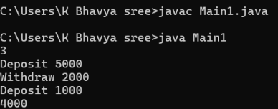
2. import java.util.*;

class Driver {
String name;

Driver(String name) {
this.name = name;
}
}

class Rider {
String name;

Rider(String name) {
this.name = name;
}
}

class Vehicle {
String number;

Vehicle(String number) {
this.number = number;
}
}

// Parent class
abstract class Ride {
abstract int calculateFare(int distance);
}

// Bike
class Bike extends Ride {
int calculateFare(int distance) {
return distance * 5;
}
}

// Cab
class Cab extends Ride {
int calculateFare(int distance) {
return distance * 12;
}
}

// Auto
class Auto extends Ride {
int calculateFare(int distance) {
return distance * 12;
}
}

public class Main {
public static void main(String[] args) {

Scanner sc = new Scanner(System.in);

int n = sc.nextInt();

for (int i = 0; i < n; i++) {

String type = sc.next();
int distance = sc.nextInt();

try {
if (distance <= 0) {
throw new Exception("Invalid distance");
}

Ride ride;

if (type.equals("Bike")) {
ride = new Bike();
}
else if (type.equals("Cab")) {
ride = new Cab();
}
else if (type.equals("Auto")) {
ride = new Auto();
}
else {
throw new Exception("Invalid ride type");
}

System.out.println(ride.calculateFare(distance));

} catch (Exception e) {
System.out.println("Invalid booking");
}
}

sc.close();
}
}
Input:
3
Bike 10
Cab 15
Auto 8
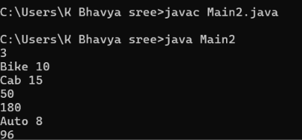
3. import java.util.Scanner;

class Vehicle {
String vehicleNumber;
double rentPerDay;

Vehicle(String vehicleNumber, double rentPerDay) {
this.vehicleNumber = vehicleNumber;
this.rentPerDay = rentPerDay;
}

double calculateRent(int days) {
return rentPerDay * days;
}
}

class Car extends Vehicle {

Car(String vehicleNumber, double rentPerDay) {
super(vehicleNumber, rentPerDay);
}

@Override
double calculateRent(int days) {
return rentPerDay * days;
}
}

class Bike extends Vehicle {

Bike(String vehicleNumber, double rentPerDay) {
super(vehicleNumber, rentPerDay);
}

@Override
double calculateRent(int days) {
return rentPerDay * days * 0.90;
}
}

class Truck extends Vehicle {

Truck(String vehicleNumber, double rentPerDay) {
super(vehicleNumber, rentPerDay);
}

@Override
double calculateRent(int days) {
return rentPerDay * days * 1.20;
}
}

public class Main3 {

public static void main(String[] args) {

Scanner sc = new Scanner(System.in);

int N = sc.nextInt();

for (int i = 0; i < N; i++) {

int vehicleType = sc.nextInt();
String vehicleNumber = sc.next();
double rentPerDay = sc.nextDouble();
int days = sc.nextInt();

Vehicle vehicle;

if (vehicleType == 1) {
vehicle = new Car(vehicleNumber, rentPerDay);
}
else if (vehicleType == 2) {
vehicle = new Bike(vehicleNumber, rentPerDay);
}
else {
vehicle = new Truck(vehicleNumber, rentPerDay);
}

double totalRent = vehicle.calculateRent(days);

System.out.printf("%s %.2f%n", vehicleNumber, totalRent);
}

sc.close();
}
}
Input:
3
1 CAR101 2000 3
2 BIKE201 500 4
3 TRUCK301 3000 2
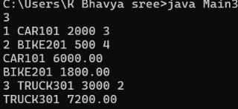
4. import java.util.Scanner;

interface Payment {
void pay(double amount);
}

class CreditCardPayment implements Payment {
public void pay(double amount) {
System.out.println("Credit Card payment: " + amount);
}
}

class UPIPayment implements Payment {
public void pay(double amount) {
System.out.println("UPI payment: " + amount);
}
}

class NetBankingPayment implements Payment {
public void pay(double amount) {
System.out.println("Net Banking payment: " + amount);
}
}

abstract class PaymentProcessor {
abstract double processPayment(Payment payment, double amount);
}

class OnlinePaymentProcessor extends PaymentProcessor {

@Override
double processPayment(Payment payment, double amount) {

if (payment instanceof CreditCardPayment) {
return amount * 1.02; // 2% fee
}
else if (payment instanceof UPIPayment) {
return amount * 1.01; // 1% fee
}
else if (payment instanceof NetBankingPayment) {
return amount * 1.015; // 1.5% fee
}

return amount;
}
}

public class Main5 {
public static void main(String[] args) {

Scanner sc = new Scanner(System.in);

int N = sc.nextInt();

PaymentProcessor processor = new OnlinePaymentProcessor();

for (int i = 0; i < N; i++) {

int paymentType = sc.nextInt();
double amount = sc.nextDouble();

Payment payment;

if (paymentType == 1) {
payment = new CreditCardPayment();
}
else if (paymentType == 2) {
payment = new UPIPayment();
}
else {
payment = new NetBankingPayment();
}

double finalAmount =
processor.processPayment(payment, amount);

if (paymentType == 1) {
System.out.printf("CreditCard %.2f%n", finalAmount);
}
else if (paymentType == 2) {
System.out.printf("UPI %.2f%n", finalAmount);
}
else {
System.out.printf("NetBanking %.2f%n", finalAmount);
}
}

sc.close();
}
}
Input:
3
1 1000
2 2000
3 5000
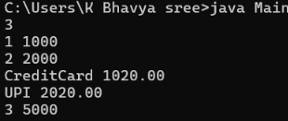
5. import java.util.*;

public class Solution {

public static void main(String[] args) {

Scanner sc = new Scanner(System.in);

try {
int a = sc.nextInt();
int b = sc.nextInt();

System.out.println(a / b);
}
catch (InputMismatchException e) {
System.out.println(e.getClass().getName());
}
catch (ArithmeticException e) {
System.out.println(e);
}

sc.close();
}
}

